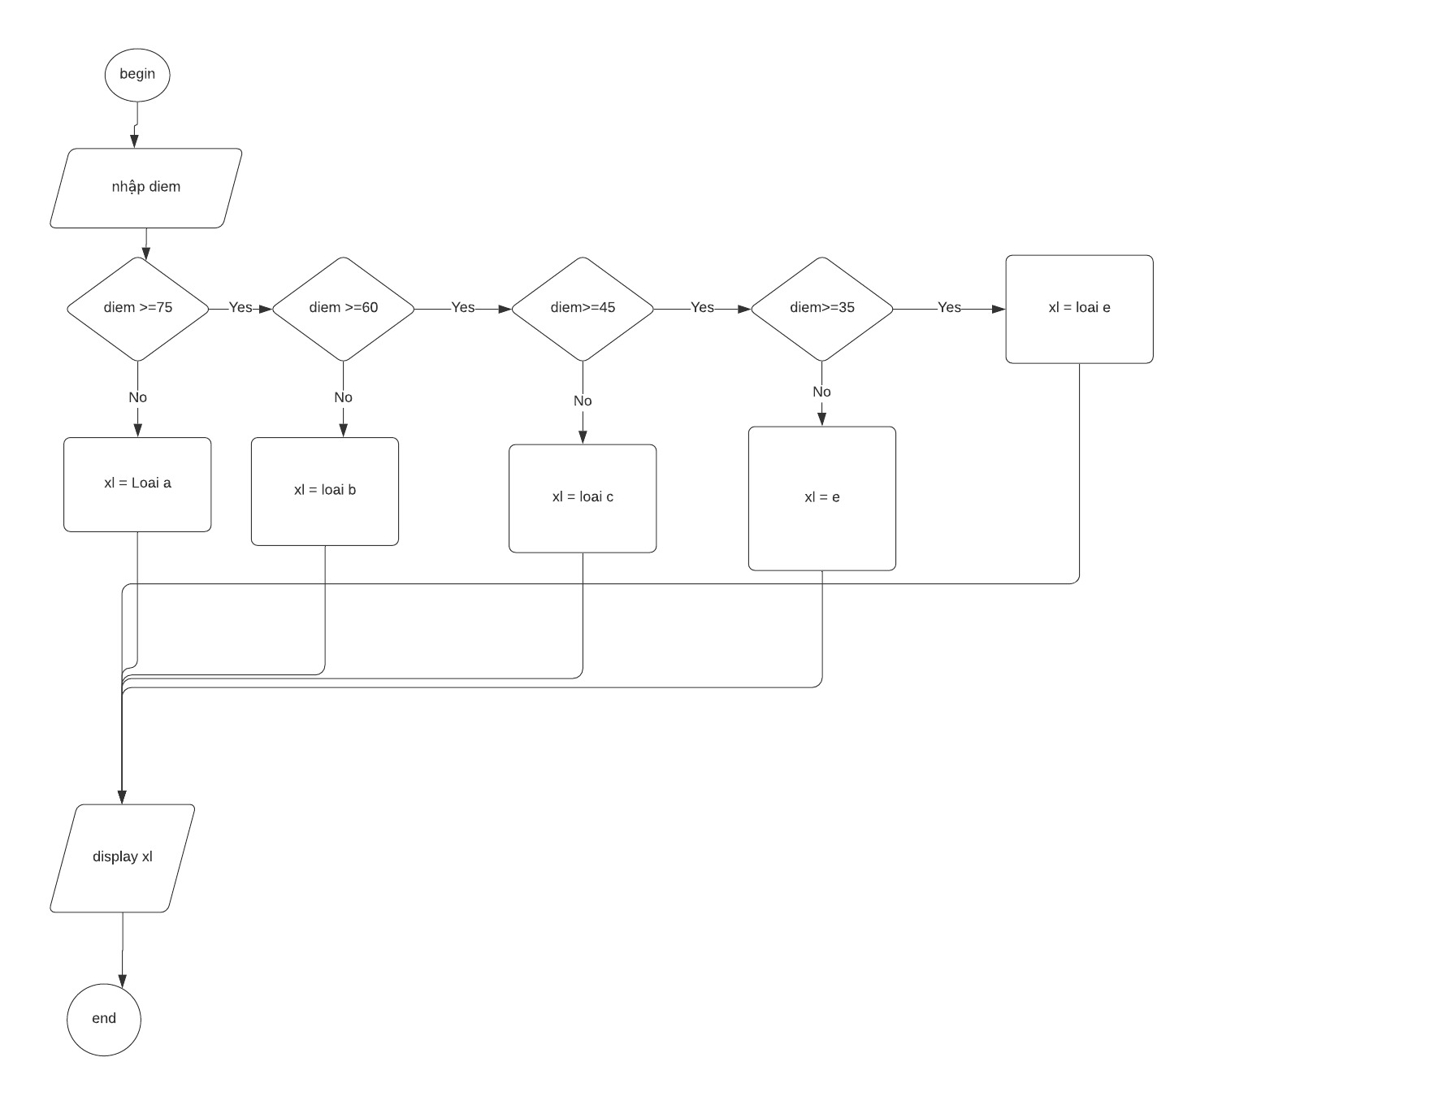

Begin

Input diem

if diem>= 75

xl = loai A

else

if diem >= 60

xl = loai B

else

if diem >= 45

xl = loai C

else

if diem >=35

xl = loai D

else

xl loai E

end if

end